

Christmas Wish List 2025
- Selection boxes
- Savoury biscuit selection
- Nuts & dried fruits
- Sweets
- Tinned fruit
- Tinned custard
- Tinned sardines & mackerel
- Tinned meat
- Tinned vegetables
- Toiletries for men and women

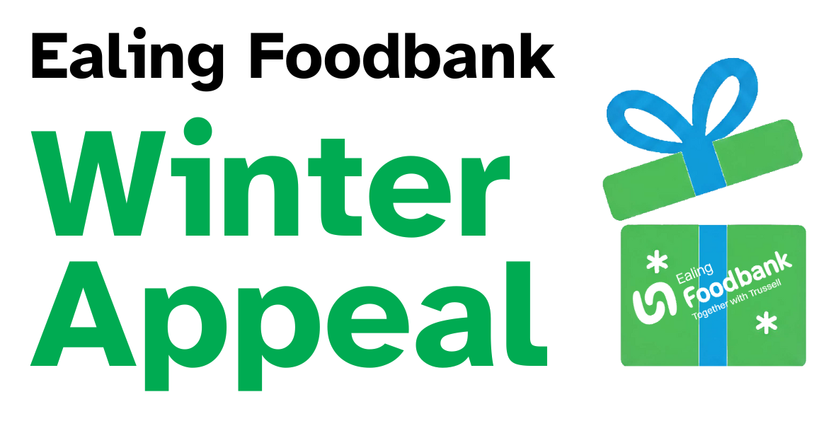
Or give a financial gift this winter and help Ealing Foodbank to offer hope and support to people in crisis.


You can also purchase our most urgently needed items on GiveToday for delivery straight to us.


